Presenter Biography: Mary Abbajay

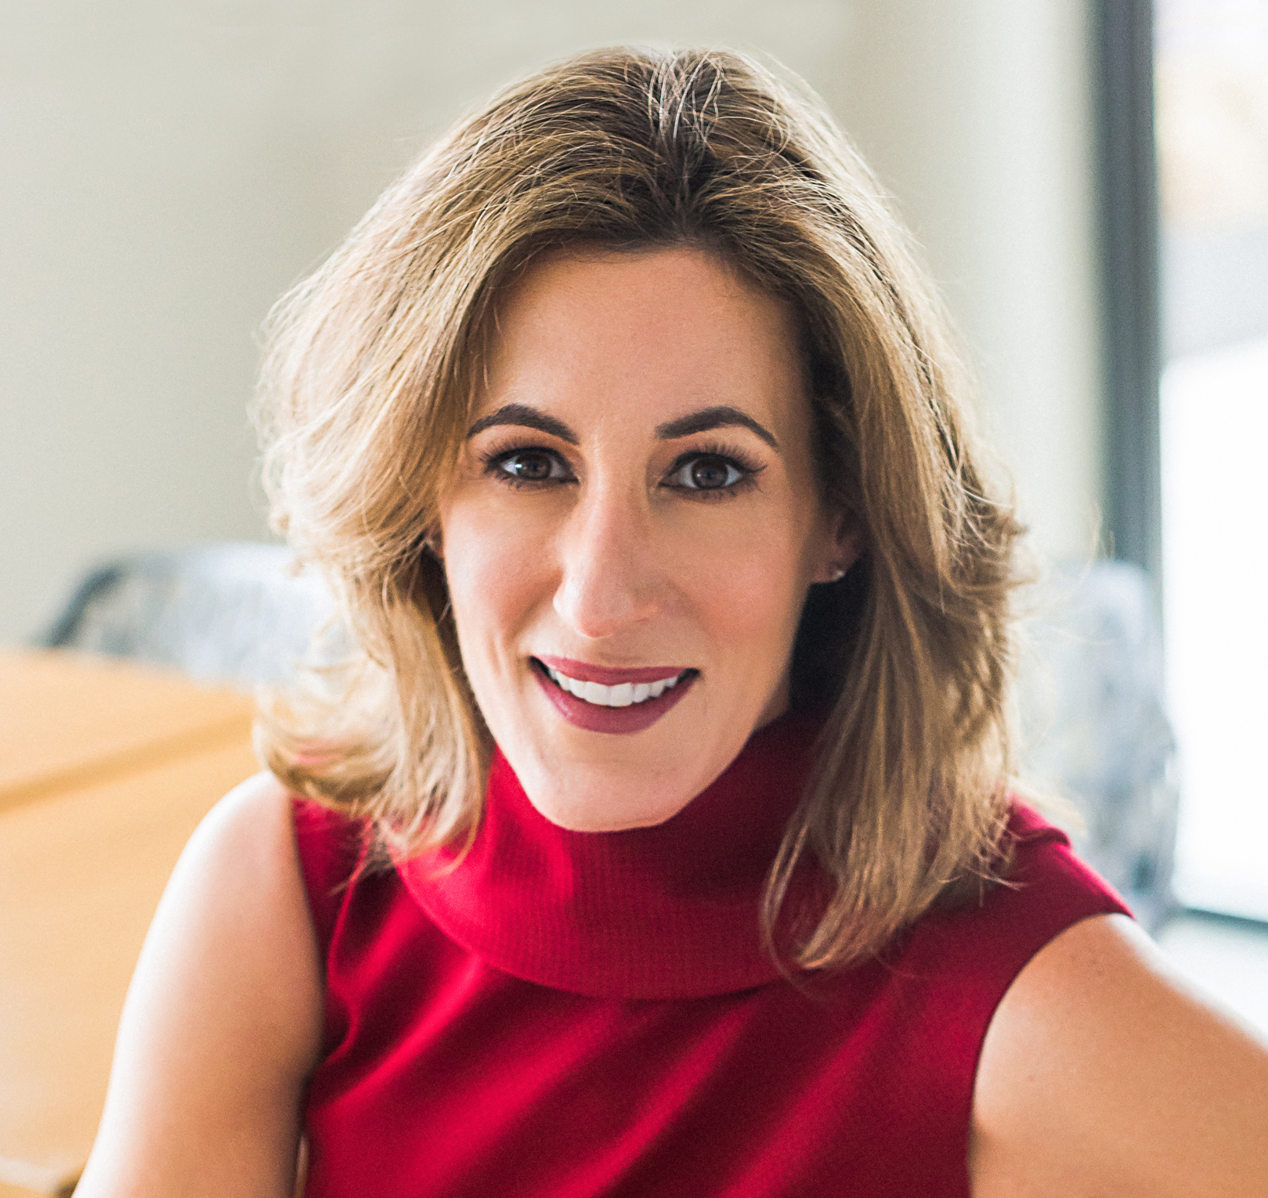
Mary Abbajay, author of the best-selling Managing Up: How to Move Up, Win at Work, and Succeed with Any Type of Boss is the president of Careerstone Group, LLC, a full service organizational and leadership development consultancy that delivers leading-edge talent and organizational development solutions to business and government. As a sought-after author, speaker, consultant, and trainer, Mary helps clients develop the strategies, skills and sensibilities needed for success in the 21st century. Her expertise lies in helping clients create dynamic and productive workplaces that foster professional and personal excellence and growth. Mary is a frequent expert contributor for television, radio and print publications where she provides practical leadership and career advice. In addition to her role as a Forbes.com contributor, her work and advice have appeared in the New York Times, Harvard Business Review, Fast Company, Forbes, The Financial Times, Money Magazine, Southwest Airlines Magazine, Monster, and the BBC.

In 2010, Mary was named as one of Washington Business Journal’s Women Who Mean Business and was a Smart CEO Brava Award recipient in 2017.

Email: mary@careerstonegroup.com
Phone: 202-965-1144
Twitter: @maryabbajay
LinkedIn: www.linkedin.com/in/mary-abbajay-managingup/
YouTube: www.youtube.com/user/maryabbajay
Websites: www.careerstonegroup.com | www.managingupthebook.com

