2019 FLEX SUCCESS® AWARD NOMINATION FORM
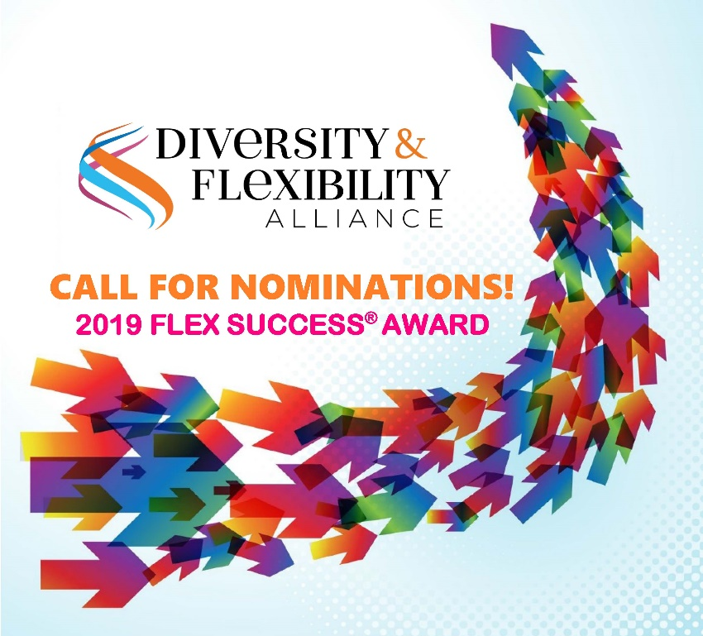
The Attorney Nominee for the Flex Success® Award should meet the following criteria:

- Be a Partner at an Alliance member organization at the time of nomination and award acceptance;
- Is currently working a reduced hours schedule, and has worked a reduced hour schedule for at least one year;
- Can identify a Client who knows the attorney is working a reduced hours schedule and is crucial to the attorney’s success;
- The Partner and Client MUST BE present to receive their awards at the Alliance’s conference on November 7, 2019 in Washington, DC.

To nominate a Partner from a member firm, please answer the following questions in this fillable PDF form and send your responses to Jane Caldeira, Manager of Communications, at jane@dfalliance.com by June 7, 2019. Please include a link or copy of the nominee’s bio.

1. NOMINATOR CONTACT INFORMATION:

Firm Name:
Email Address:
Phone Number:
Office Location:

- NOMINEE PARTNER CONTACT INFORMATION:
Partner Nominee Name:
Firm Name:
Email Address:
Phone Number:
Office Location:
Is Nominee an Equity or Non-Equity Partner?

- Please describe the Partner nominee’s reduced hours arrangement, including, but not limited to, the following: percentage of full-time worked, length of time on the schedule, how the hours are worked (i.e. shorter days, fewer days per week, annualized hours, or other).

- Describe the specific reasons why the Partner nominee’s arrangement is considered successful.

- CLIENT NOMINEE INFORMATION (Please include contact information for a representative of the client with whom the Partner would share the award):

Client Nominee Name:
Title:
Company Name:
Email Address:
Phone Number:
Office Location:

- Describe how the Client contributed to making this a successful arrangement.

- Describe the Partner nominee’s demonstrated firm citizenship (e.g., firm leadership, committee involvement, community service, mentorship, etc.).

- Please feel free to add any other information that demonstrates why this Partner nominee should win the 2019 Flex Success® Award.

If you have any questions, please contact Jane Caldeira at jane@dfalliance.com.

